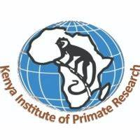

INTERNAL MEMO
Ref: KIPRE/ADM/HRMAC/03/2025
Date: 14/4/2025
From: Mr. Patrick Manene- Secretary Human Resource Advisory Committee
To: 1. Dr. Lucy Ochola-Chairperson
2. Dr. Atunga Nyachieo
3. Dr. Jael Obiero
4.Dr. Daniel Chai
5.Dr. Stanslaus Kivai
6.Dr. Joseph Kamau
7.Dr. George Omondi
8.Mr. Daudi Salla
9. Ms. Maimuna Alhamid
SUBJECT: HUMAN RESOURCE MANAGEMENT ADVISORY COMMITTEE MEETING
You are hereby invited for an urgent HRMAC meeting on 17TH April 2025(Thursday) at10.00 am. please be punctual.
AGENDA FOR THE MEETING.
1.Staff performance appraisal reports
2.Training needs assessment for Staff
3.Recommendation for contract renewal
4. Kipre term of service
5. Human Resource plan
Thank you.

